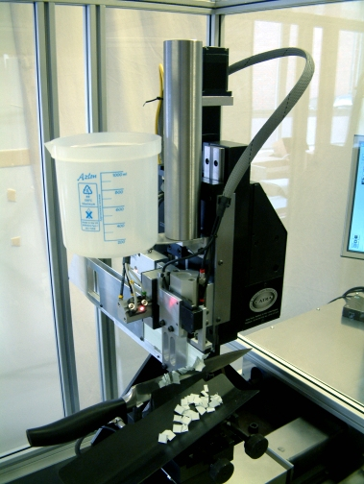
CUTTING EDGE TEST MACHINE

Designed and manufactured by

CATRA

The World’s Knife Technology Organisation

See the video at www.catra.org

- Measures the sharpness and edge life of blades, knives and cutters for quality control, research, development and competitor product evaluation.

- Quickly and accurately provides important cutting performance data.

- Fully automatic windows based system allows operator to multi task

- Fully programmable to allow operation to standard or user's own specific requirements.

- 24 in use throughout the World.

- The only proprietary cutting test machine on the market.

- Designed to International Standard BS EN ISO 8442-5- 2004.

- Very fast, low labour cost machine, ideal for large sample size testing and large development projects or daily QA testing or test house work.
Available directly from the manufacturers
CATRA Henry Street, Sheffield S3 7EQ United Kingdom
Tel: +44 (0)114 276 9736 Web: http://www.catra.org
Fax:+44(0 )114 272 2151 Email: info@catra.org
The Need for Sharpness Measurement
CATRA has been involved in the testing of performance characteristics of blades for over 50 years. In particular the problems of evaluating the cutting ability have been studied using various manual and mechanical methods. This knowledge has enabled CATRA to design an automatic test machine that meets the requirements of consumers, manufacturers and in 1988, standards organisations alike.
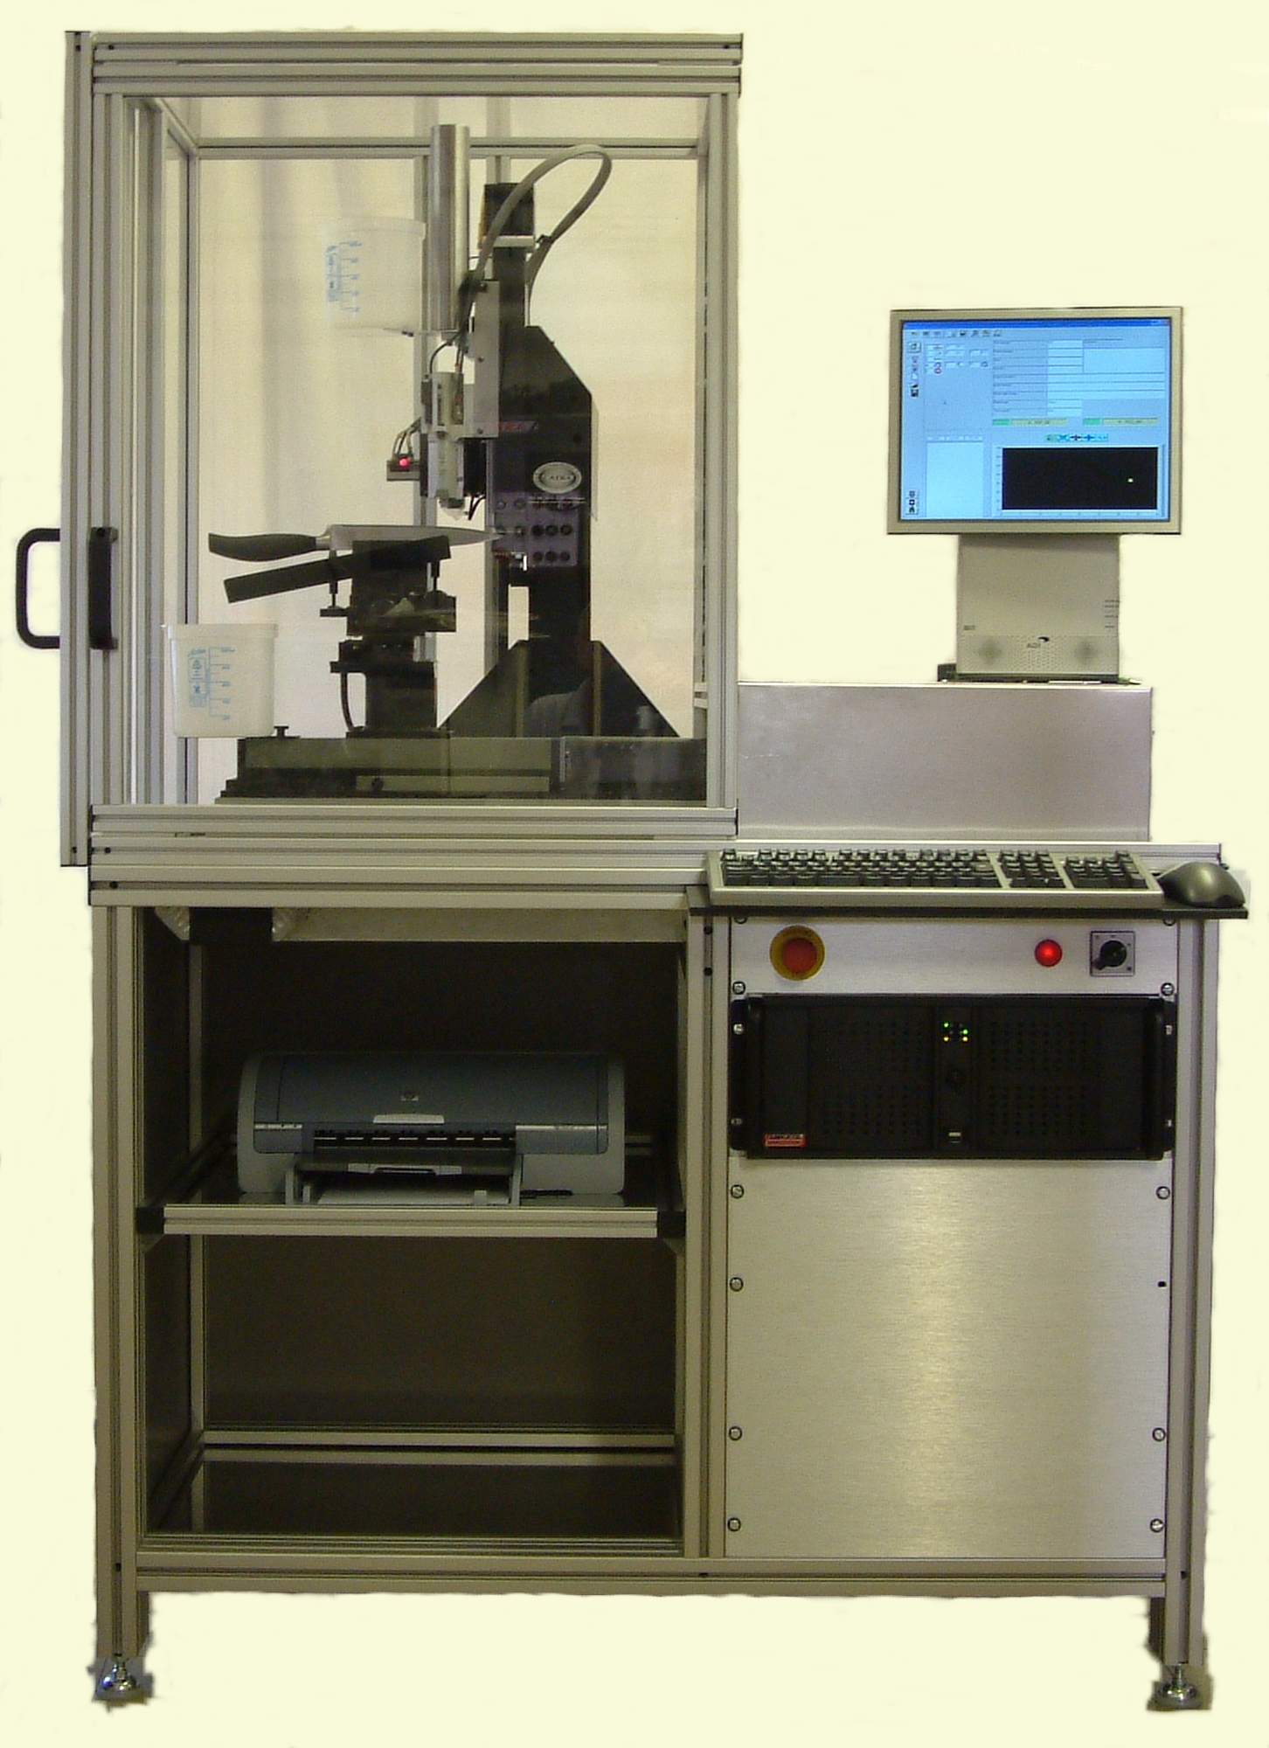
The need for such a cutting performance test is internationally agreed:

- to compare objectively various knife blades and determine which one is superior to another

- to monitor the consistency of quality of cutting performance against the norm of manufacturing, to be sure that the knives are within the standard values agreed upon

- To be used as a development tool to enable research into the optimum steel, heat treatment, surface coating, edge geometry and finishing operations to suit the application.

The International Cutting Test Standard BS EN ISO 8442-5: 2004

A group of specialists from various countries have developed a standard within the ISO Standards Committee for articles in contact with food. It specifies the detailed method and sharpness specification for knives for the preparation of food. However, the test is ideally suited to other types of blades, including:

- Kitchen and professional knives
- Handicraft, utility and tool knives
- Surgical blades
- Machine blades and cutters
- Agricultural blades
- Chisels and other wood tools

Testing Method
The principle of the test is simple. The blade is mounted in a position with the edge vertical and a pack of specially developed synthetic paper is lowered on to it. By oscillating the blade back and forth the blade cuts into the paper, the depth of the cut being the measurement of sharpness. The test media is loaded with 5% quartz, which has a mild wearing effect on the blade edge. By repeating the back and forth motion, further cuts are made, which wears the cutting edge. The measurement of cut depth at each subsequent stroke can then be plotted to produce a wear curve for each blade tested. The test produces two indications:

- ICP (Initial Cutting Performance) representing the cutting ability (sharpness) of the blade as supplied

- TCC (Total Card Cut) which represents the life of the blade by giving a measure of its total cutting ability.

The test is designed for straight or nearly straight blades. However, specially modified machinery can be provided for circular or curved blades.
Specification

Test Machine Free standing with own frame and safety screen, which are constructed in anodised aluminium and black oxide treated steel.

Test Stroke - 0 to 128 mm
Test Cutting Speed - 0 to 150 mm/second
Test Load - 25 and 50 N
Optional - 0 to 25 N counter-balance and weights
Max depth of media - 50 mm
Overall vertical capacity( max blade width) - 105 mm (incl 50 mm of cut)
Size - 1700 x 1800 x 2000 mm
Weight - 350 Kg
Typical test time plain edge blade - 15 mins ( 60 cutting strokes)
Test time plain edge with autoset feature - 10 mins
Typical test time serrated edge blade - 50 mins (200 cutting strokes)
Test time serrated edge with autoset feature - 38 mins
Electrical supply requirements - 240v or 110 v AC single phase ( specify)
Compressed air requirements - 3 l / min at 6 bar

Computer Hardware

The test machine and control software (operating in the current standard Windows environment) is designed to operate on the computer system supplied with the following minimum specification:

Qty | Description
1 | IBM compatible computer (current market minimum specification)
1 | 15" Flat screen
1 | 3½" Floppy Disc Unit/ CD Unit
1 | Serial Port/ Parallel Port/USB Port/ Network card
1 | 16 Bit Expansion Slot
1 | Printer (Parallel) with graphics capability with either Epson or IBM Emulation Modes

The TEST MEDIA is specially formulated card with controlled Silica content
of 5% supplied in:

10 kg packs
Thickness 0.31 mm ±0.02 mm
Weight 200 g ±10g/m²
Cut into strips 10 mm wide x 625 mm long

Machine Description

The CATRA Cutting Test Machine is generally as shown in the drawings on the adjoining page. The machine comprises of a rigid metal fabricated frame (Base & Cantilever) to which all major sub-assemblies are mounted. It is configured such that the blade to be tested is fixtured, edge upwards, on a reciprocating table mounted onto the base of the machine whilst the test media (card) is applied, under load, onto the knife edge from the cantilever.

The blades to be tested can be easily clamped into the self-centring vice, which has a jaw design to compensate for blade thickness and taper in two directions. The centre line of any blade is therefore always the same datum; adjustable pillars support the blade and are used to set the attitude of the test portion of the cutting edge to as near level as possible. This design means that any length of blade can be accommodated, provided that the test portion is positioned over the vice jaws and is therefore supported. The equipment is supplied with a standard vice which covers a wide range of blade types, but optional special jaws can be supplied to accommodate small or unusually shaped blades.

The vice is mounted on a horizontal low friction slide which during the test is free to allow lateral float of the blade whilst cutting through the media, but returns to the fixed datum position for the beginning of each new cutting block. This slide is in turn mounted onto a horizontal table, which facilitates the longitudinal motion of the blade for cutting strokes. Drive to the table and therefore the blade is via a servo motor and lead screw arrangement, which allows precise positional and speed control over all or any part of the table's stroke. Therefore the test is carried out with a constant speed and motion envelope.

The test media (strips of card which are pneumatically clamped during cutting) is mounted in a holder with a capacity of 50 mm cutting thickness on a vertical low friction slide. Test load is applied vertically to the slide and therefore the media, by a calibrated weight. The method of lowering the media to the blade, together with the vice jaw design allows a full range of blade widths to be accommodated. Measurement of the amount of the card cut is achieved electronically. At the beginning of each new test and after each cut through the 'block' of media, the card is fed forward automatically by a pneumatic indexing system.

Operation of the machine is totally automatic, except for the loading, setting up of the blade and replenishing the packs of cutting media. An optional blade height set up feature ( Autoset) is available which simplifies set up and reduces test time by approximately 25% the machine functions are controlled by a microprocessor based unit, which switches electro-pneumatic devices and controls the motor under instruction of the resident program. This unit is in turn a slave to a host computer of IBM PC compatibility. The function of the PC is to provide the operator interface at the keyboard and to manage the test data, parameters, generate test reports and allow rapid comparison of current test data within Access database and Excel spreadsheet environments.

The Software is Windows based Using a standard windows interface that is familiar from most applications greatly reduces the time taken to train people to use the software and making the package intuitive to use. The majority of controls are activated by buttons with icons rather than word descriptions, only the data input concerning blade details are vocabulary based, which allows use of Multilanguage versions including French, German, Spanish and Japanese. Real time displays of data and results are both numerically and graphically shown on the main test screen. Various display options are available from the user interface screen with the machine in run mode. The operator can, whilst a test is in motion, interrogate the data base and analysis previous test data without significantly affecting test speed.
Although many blades are tested to the specific test parameters of ISO 8442.5 the machine and software systems flexibility allows the operator to design, develop, and store user tests, thereby a very wide range of blade sizes and types to be accommodated .
Data generated by the test software is stored as an excel file and all test and blade information is readily analysed and searched by the built in Access database system., as a result large numbers of user selected tests can be compared. Database queries can easily be designed by the machine user.

Optional 3 axis load measuring platform can be mounted below the blade vice to enable measurement of all cutting forces. This is useful as an instrument to aid in the development of knife edges, surface treatments and coatings. The additional load measuring package includes a load cell, all cables, computer interfaces and software. The unit is capable of measuring forces to a resolution of 0.1N with an accuracy of +/-0.25 N. The software is totally integrated into the operating software giving flexibility of force data capture and real time display. Resultant test data can be stored to the database.

Optional single axis load measuring system to determine the forces along the blade only is offered. This system utilises linear slide motor feedback current and is calibrated to give force measurements to a resolution of 0.5N with an accuracy of +/-1N. Again the software for this option is totally integrated into the test software allowing flexibility of measurement.

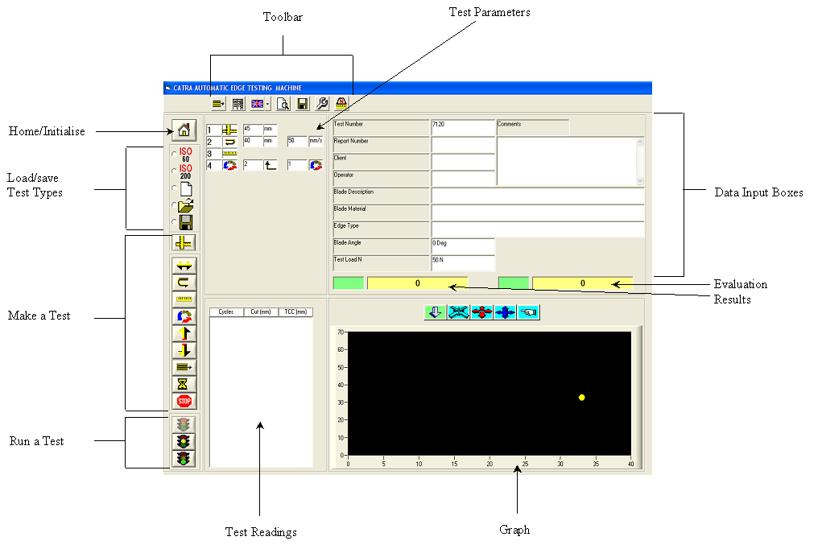
Optional calibration package This unit complete with specific hardware is to enable accurate physical and dynamic (cutting) calibration of the machine. It is integrated into the standard software and allows calibration data to be stored within the system database. With this option, calibration takes around 1 hour, thereby encouraging users to regularly check the system calibration. The system adjustments required as a result of the dynamic calibration are automatically applied within the machine running software and the test report is marked accordingly.

Test screen layout

Typical comparative chart of knives tested, showing extremely poor results to very good results
The following companies/organisations have the CATRA cutting test machine within their facilities
Dexter Russel ----USA Cutco/Alcas -----USA J A Henckels ---- Germany
World Kitchen ----USA Richardson ----UK CATIM ---- Portugal
Buck Knives ----USA Goutebarge ---- France Leatherman ---USA
Fiskars Montana ---- Italy Madrid University ----Spain Arcos ---- Spain
FGW ----Germany Wenger ----Switzerland Bettcher ----USA
Spyderco ----USA Imperial Schrade ----USA ICEL ---- Portugal
W R Case ---- USA Stanley Tools ----UK Master Cutlery ( Global Knives) ----Japan
and of course CATRA, we have 2, one for straight blades and one for circular blades, cutters and knives, with
which we independantly have tested knives for over 700 companies Worldwide
The following companies will receive machines during 2004
American Saw ( Lenox)----- USA

Please visit our web site to see the latest video of the machine in operation
www.catra.org

